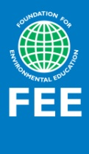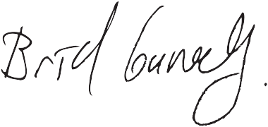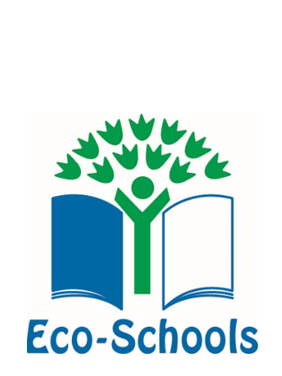

Eco-Schools is a fundamental initiative, which encourages young people to engage in their environment by allowing them the opportunity to actively protect it. It starts in the classroom, expands to the school and eventually fosters change in the community at large.

The Eco-Schools programme extends from kindergartens to universities and is implemented in over 64 countries, involving 50,000 schools and institutions, over 17 million students and 1.3 million teachers.

Eco-Schools is an international programme of the Foundation for Environmental Education (FEE). **www.ecoschools.global**

Foundation for Environmental Education

Scandiagade 13, Copenhagen 2450, Denmark

+45 7022 2427

[info@fee.global](mailto:info@fee.global)

[www.fee.global](http://www.fee.global)

This is to certify that

**NAME OF SCHOOL**participates in the pilot phase of Eco-Schools Twinning Project.

Bríd Conneely

International Eco-Schools Director

**Eco-Schools Twinning Project**

**ECO-SCHOOLS**